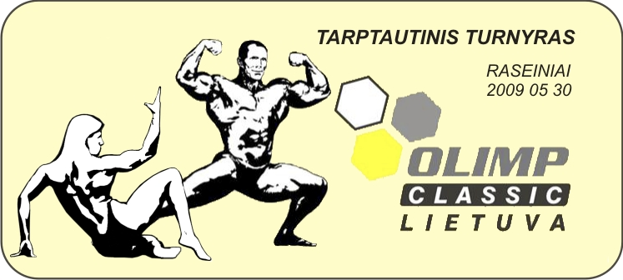

I N V I T A T I O N
TO INTERNATIONAL MEN’S BODYBUILDING AND BODYFITNESS TOURNAMENT
II “OLIMP CLASSIC LITHUANIA 2009”
DATE: May 30th.
PLACE: Raseiniai Cultural Center (Vytauto Didziojo 10) Raseiniai, Lithuania.
ORGANIZERS: Sports Club VIFO, weekly newspaper ALIO RASEINIAI and LITHUANIAN BODYBUILDING FEDERATION
SANCTIONED: By the Lithuanian Bodybuilding Federation.
TOURNAMENT DIRECTOR: Arvydas Mickus
CATEGORIES:
Two men’s bodybuilding categories – up to 85 and over 85 kg.
Overall women‘s bodyfitness category.
The competition is held according to the rules of the IFBB. Top 3 finishers of each category will participate in the overall category.
PARTICIPANTS: The delegacies include 3 (three) sportsmen and 1 (one) official of the team.
TIME SCHEDULE: Arrivals: from 12.00 on the 29th of May to the Country tourism homestead KARPYNE which is situated near 173 km of the highway Vilnius-Klaipeda or 137 km if following the direction Klaipeda-Vilnius (www.karpyne.lt ). Sportsmen coming at 8.00 PM on the 29th of May to Vilnius airport will be taken with car to KARPYNE. In the morning on 31st of May sportsmen from KARPYNE will be taken to Vilnius airport.
REGISTRATION: 30th of May: Weigh-in: 10.00 – 11.00 at the contest area.
Beginning of contest : 18.00
ACCOMMODATION: The accommodation will be free for the athletes participating in the tournament and the officials of the team. The 29th of May is the arrival day, the 31st – departure.
PRIZES:
Place Men‘s bodybuilding Women‘s bodyfitness
I 1000 EUR 300 EUR
II 500 EUR -
III 300 EUR -
PRIZES: Other sportsmen will be awarded with trophies also.
CONTACTS: Please inform us about your intentions to participate and your e-mail addresses for contacts till May 20th, 2009.
Tournament director Arvydas Mickus

Best regards
Remigijus Bimba
Mob. +370 610 23144
info@rbimba.lt
http://www.rbimba.lt

