THE NORWEGIAN FEDERATION
INVITES YOU TO OSLO
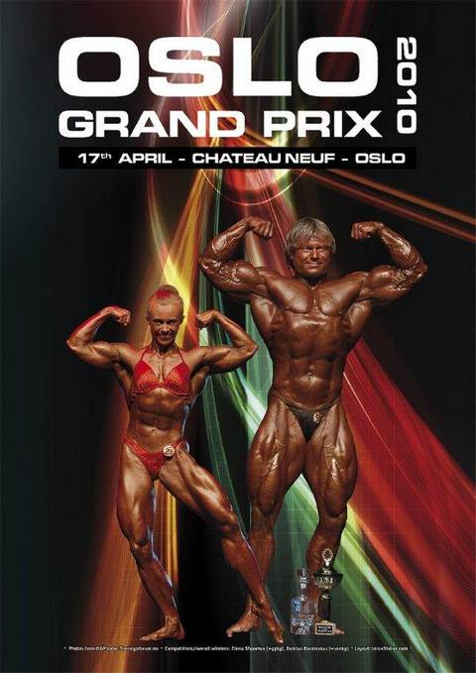
Oslo Grand Prix will be held on April 17th this year. Registration and weigh-in on Friday, April 16th, at 18:00 - 20:00 hours. This annual contest promoted by the Norwegian Bodybuilding and Fitness Federation [NKF] will include the following categories:
Men’s BODYBUILDING: 80 kg; 90 kg; 100 kg; +100 kg and overall
Women’s BODYBUILDING: one open category
Men’s CLASSIC BODYBUILDING: 180 cm; +180 cm
Women’s CLASSIC BODYBUILDING: 163 cm; +163 cm
Women’s BODY FITNESS: 163 cm; +163 cm
PRIZE MONEY:
MEN’S BODYBUILDING OVERALL:
1st place - 2000 Euro + specially designed gold ring
2nd place - 1000 Euro
3rd place - 500 Euro
WOMEN’S BODYBUILDING OPEN:
1st place - 1000 Euro
OVERALL MEN’S CLASSIC BODYBUILDING:
1st place - 750 Euro
OVERALL WOMEN’S CLASSIC BODYBUILDING:
1st place - 750 Euro
OVERALL WOMEN’S BODYFITNESS:
1st place - 750 Euro
This year contest will take place at the Chateau Neuf ((Det Norske Studentersamfund).
More info at: www.oslograndprix.comand www.nkf-ifbb.no (in English)
All competitors must be nominated by their National Federations. The deadline for sending the Final Entry Form is April 3rd, 2010. Entry Form are available at the NKF’s website and must be sent by e-mail to the NKF's Webmaster Jorun Steine: web@nkf-ifbb.no

