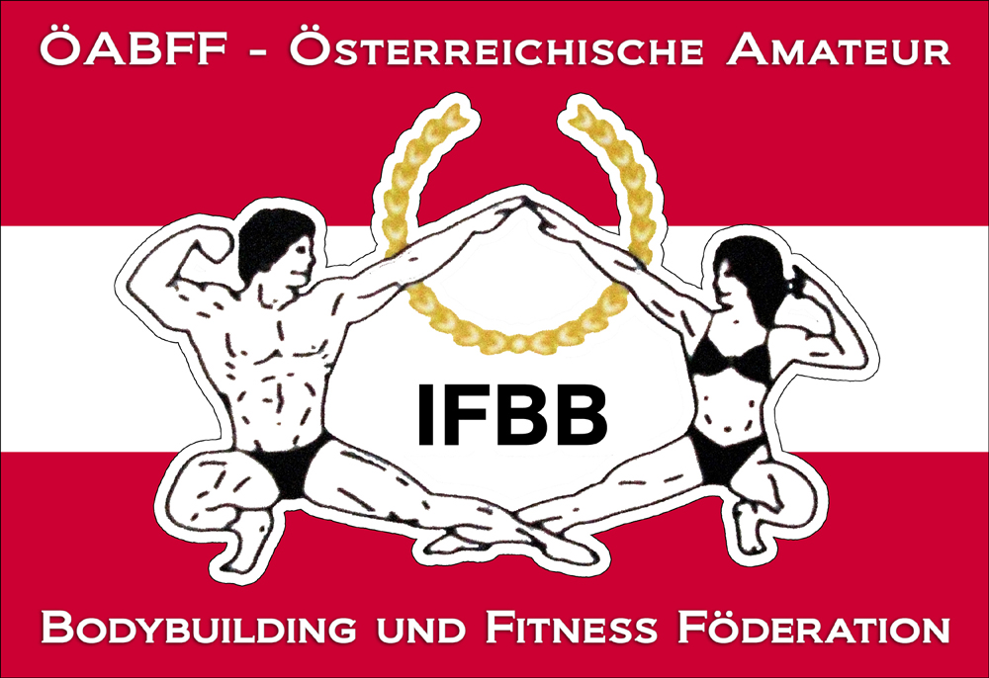

IFBB International Austria Cup 2012
And
IFBB-Austria Newcomers Championship
29th of September 2012 (Saturday)
Angererstraße 14, 1210 Vienna,

Date: 29th of September 2012
Organizer: Austrian Amateur Bodybuilding and Fitness Federation/IFBB-Austria
Venuesite: Haus der Begegnung, Angererstraße 14, 1210 Vienna,

Weigh in: 10.00 – 12.00

Competition: Prejudging: 12.00; Finals: 17.00

Entry form: Please not later than 14th of September 2011 to w.schober@ifbb-austria.at

Categories:
Juniors Classic Bodybuilding: open
Juniors Men Bodybuilding: open
Masters Men Classic Bodybuilding: open
Masters Men Bodybuilding: open
Bikini-Fitness: open
Women Bodyfitness: open
Women Bodybuilding: open
Mixed Pairs
Men Classic Bodybuilding: -175cm/ +175cm
Men Bodybuilding: -85 kg/-95 kg/+95kg

Rewards: Certificates for all finalists, cup for first 3 of each category.

Tickets:
Advance Sale via office@ifbb-austria.at (valid until 22nd of September)
Prejudging: € 10.-,
Prejudging + Finals : € 30.- (free seating)

Sale
Prejudging: € 15.-,
Prejudging + Finals : € 35.- (free seating)

THE IFBB HAS BANNED ALL TANS THAT CAN BE WIPED OFF. AN OFFICIAL WILL CHECK THE TAN OF ALL ATHLETES BACKSTAGE AND IF THE TAN COMES OFF BY SIMPLY WIPING, THE ATHLETE WILL BE TOLD TO REMOVE THE TAN BEFORE GOING ON STAGE.

Looking forward to welcome you all in the City of Waltz right in the heart of Europe.

Dr. Wolfgang Schober
President IFBB-Austria

