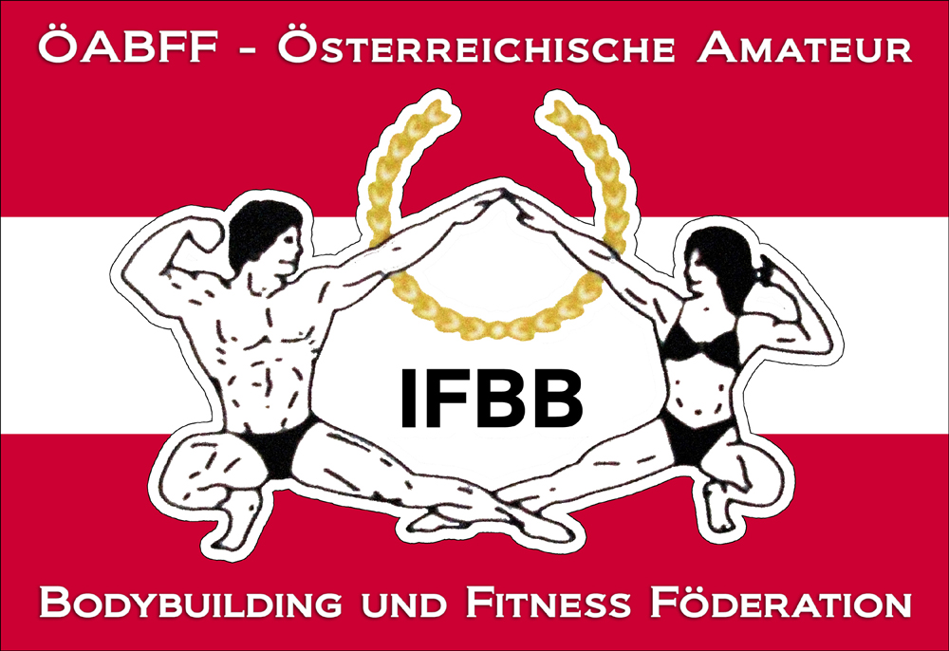

IFBB International Austria Cup

28th of September (Saturday) 2013
Haus der Begegnung Angererstraße 14, 1210 Wien

Date: 28th of September 2013
Organizer: Austrian Amateur Bodybuilding and Fitness Federation/IFBB-Austria
Venuesite: Haus der Begegnung Angererstraße 14, 1210 Wien
Weigh in: 10.00 – 12.00
Competition: Prejudging: 12.00; Finals: 17.00
Entry form: Please not later than 7th of September 2013 to w.schober@ifbb-austria.at

Categories:
Junior Men Physique open
Junior Men Classic Bodybuilding: open
Junior Men Bodybuilding: open
Junior Women Bikini Fitness: open
Junior Women Bodyfitness: open

Men Physique -178cm
Men Physique +178cm

Men Classic Bodybuilding - 168 cm
Men Classic Bodybuilding - 171 cm
Men Classic Bodybuilding - 175 cm
Men Classic Bodybuilding - 180 cm
Men Classic Bodybuilding + 180 cm
Masters Men Classic Bodybuilding open

Bikini Fitness - 163cm
Bikini Fitness - 168cm
Bikini Fitness + 168cm

Masters Bodyfitness open
Women Bodyfitness: open
Women´s Physique: open
Masters Men Bodybuilding: open
Men Bodybuilding - 85 kg
Men Bodybuilding - 95 kg
Men Bodybuilding + 95 kg

Rewards: Certificates for all finalists, cup for first 3 of each category.
Tickets:
Advance Sale via www.ifbb-austria.at (valid until 7th of September 2013)
Prejudging: € 10.-,
Prejudging + Finals : € 30.- (free seating)

At the gate
Prejudging: € 15.-
Prejudging + Finals : € 35.- (free seating)
THE IFBB HAS BANNED ALL TANS THAT CAN BE WIPED OFF. AN OFFICIAL WILL CHECK THE TAN OF ALL ATHLETES BACKSTAGE AND IF THE TAN COMES OFF BY SIMPLY WIPING, THE ATHLETE WILL BE TOLD TO REMOVE THE TAN BEFORE GOING ON STAGE.

Looking forward to welcome you all in Vienna.

Dr. Wolfgang Schober
President IFBB-Austria

