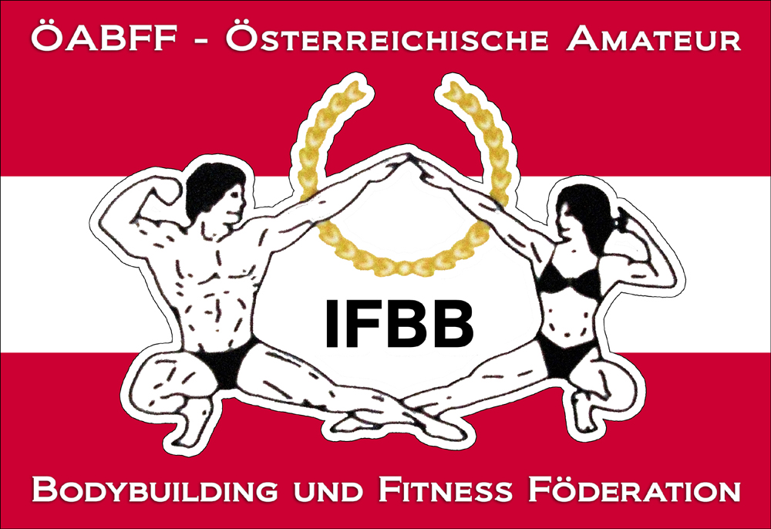

IFBB International Austrian Championship 2015

2ND of MAY 2015 (Saturday)
VAZ St. Pölten Kelsengasse 9, 3100 St. Pölten

Date: 2nd of May 2015
Organizer: Austrian Amateur Bodybuilding and Fitness Federation/IFBB-Austria
Venuesite: VAZ St. Pölten Kelsengasse 9, 3100 St. Pölten
Weigh in: 10.00 – 12.00
Competition: Prejudging: 12.00; Finals: 17.00
Entry form: Please not later than 11th of April 2014 to w.schober@ifbb-austria.at
Categories:
Junior Men´s Physique open
Masters Men´s Physique
Men´s Physique -178cm
Men´s Physique +178cm

Junior Classic Bodybuilding: open
Masters Classic Bodybuilding open
Classic Bodybuilding - 175 cm
Classic Bodybuilding over 175 cm

Junior Bodyfitness: open
Masters Bodyfitness: open
Women Bodyfitness: open
Women´s Physique: open

Junior Bodybuilding: open
Masters Bodybuilding: open
Bodybuilding - 85 kg
Bodybuilding - 95 kg
Bodybuilding + 95 kg

Mixed Pairs

Junior Bikini Fitness: open
Masters Bikini Fitness: open
Bikini Fitness - 163cm
Bikini Fitness - 169cm
Bikini Fitness + 169cm

Rewards: Certificates for all finalists, cup for first 3 of each category.

As the IFBB-Austria will celebrate its 40th anniversary in 2015 we will have a buffet (of course also including diet-food for those who will continue their season) + party with dancing right after the championship. We are glad to invite athletes and national coaches and officials from our neighboring countries to be our guests after the championships. We are looking forward to celebrate together as the IFBB-Family our 40th anniversary.

Tickets:
Advance Sale via www.ifbb-austria.at (valid until 11. April 2015)
Prejudging: € 10.-,
Prejudging + Finals : € 30.- (free seating)

At the gate
Prejudging: € 15.-
Prejudging + Finals : € 35.- (free seating)

Fantickets (at least 5 people)
Advance sale (per ticket) – 25 .- Euros
At the gate (per ticket) 30.- Euros
Fans, family members and others who are not official members of national delegations will have the opportunity to buy a voucher for the buffet + party at the gate for 15.- Euros.

THE IFBB HAS BANNED ALL TANS THAT CAN BE WIPED OFF. AN OFFICIAL WILL CHECK THE TAN OF ALL ATHLETES BACKSTAGE AND IF THE TAN COMES OFF BY SIMPLY WIPING, THE ATHLETE WILL BE TOLD TO REMOVE THE TAN BEFORE GOING ON STAGE.

Looking forward to welcome you all in St. Poelten.

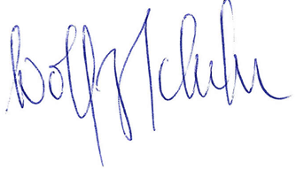
Dr. Wolfgang Schober
President IFBB-Austria

