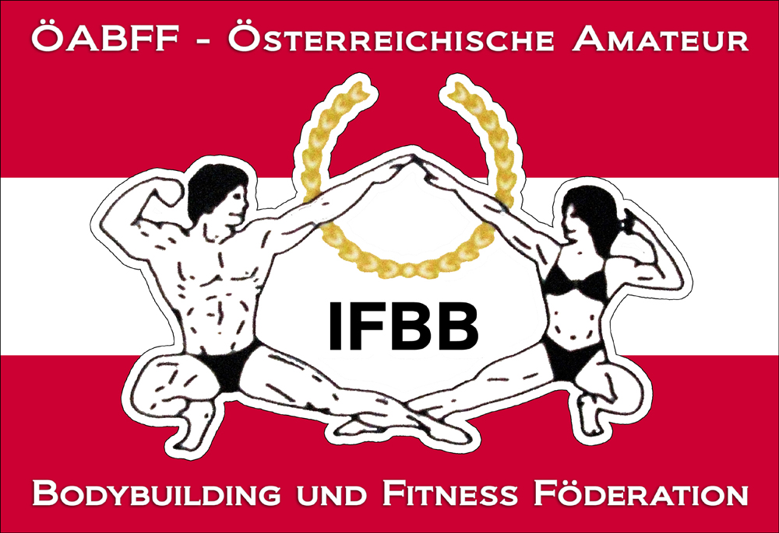

IFBB International Austria Cup 2015

20^{0th} of September 2015 (Sunday)
Kerpelystraße 11, 8700 Leoben

Date: 20th of September 2015
Organizer: Austrian Amateur Bodybuilding and Fitness Federation/IFBB-Austria
Venuesite: Sporthalle Leoben (Styria) Kerpelystraße 11, 8700 Leoben
Weigh in: 12.00 – 14.00
Competition: Prejudging: 14.00; Finals: directly after semi-finals of classes with more than 6 athletes
Entry form: Please not later than 6^{h} of September 2014 to w.schober@ifbb-austria.at
Categories:
Junior Men´s Physique open
Masters Men´s Physique
Men´s Physique -178cm
Men´s Physique +178cm

Junior Classic Bodybuilding: open
Masters Classic Bodybuilding open
Classic Bodybuilding - 175 cm
Classic Bodybuilding over 175 cm

Junior Bodyfitness: open
Masters Bodyfitness: open
Women Bodyfitness: open
Women´s Physique: open

Junior Bodybuilding: open
Masters Bodybuilding: open
Bodybuilding - 85 kg
Bodybuilding - 95 kg
Bodybuilding + 95 kg

Mixed Pairs

Junior Bikini Fitness: open
Masters Bikini Fitness: open
Bikini Fitness - 163cm
Bikini Fitness - 169cm
Bikini Fitness + 169cm

Rewards: Certificates for all finalists, cup for first 3 of each category.

Tickets:
Advance Sale via www.ifbb-austria.at (valid until 6th of September 2015)
Prejudging + Finals : € 30.- (free seating)

At the gate
Prejudging + Finals : € 35.- (free seating)

Fantickets (at least 5 people)
Advance sale (per ticket) – 25 .- Euros
At the gate (per ticket) 30.- Euros

THE IFBB HAS BANNED ALL TANS THAT CAN BE WIPED OFF. AN OFFICIAL WILL CHECK THE TAN OF ALL ATHLETES BACKSTAGE AND IF THE TAN COMES OFF BY SIMPLY WIPING, THE ATHLETE WILL BE TOLD TO REMOVE THE TAN BEFORE GOING ON STAGE.

Looking forward to welcoming you all in the home-province of Arnold Schwarzenegger. ☺

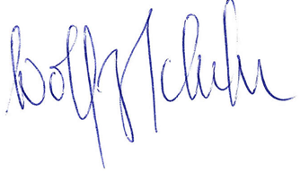
Dr. Wolfgang Schober
President IFBB-Austria

