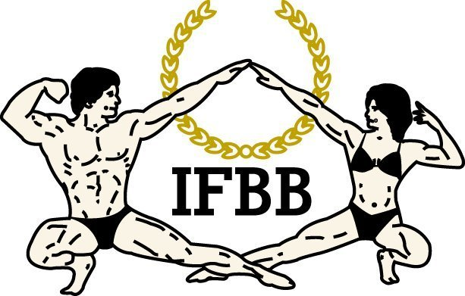

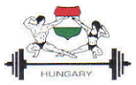

IFBB EUROPEAN CHILDREN FITNESS CHAMPIONSHIPS
&
HUNGARIAN FITNESS,
BIKINI FITNESS WORLD CUP

INSPECTION REPORT


BUDAPEST, HUNGARY

October 24 – October 26, 2015

WELCOME

The Organizing Committee of the Hungarian Bodybuilding & Fitness Federation extends a warm welcome to all IFBB National Federations to participate in the IFBB European Children Championship and Hungarian Fitness, Bikini Fitness World Cup in Budapest, Hungary, October 24 – October 26, 2015.

ABOUT BUDAPEST

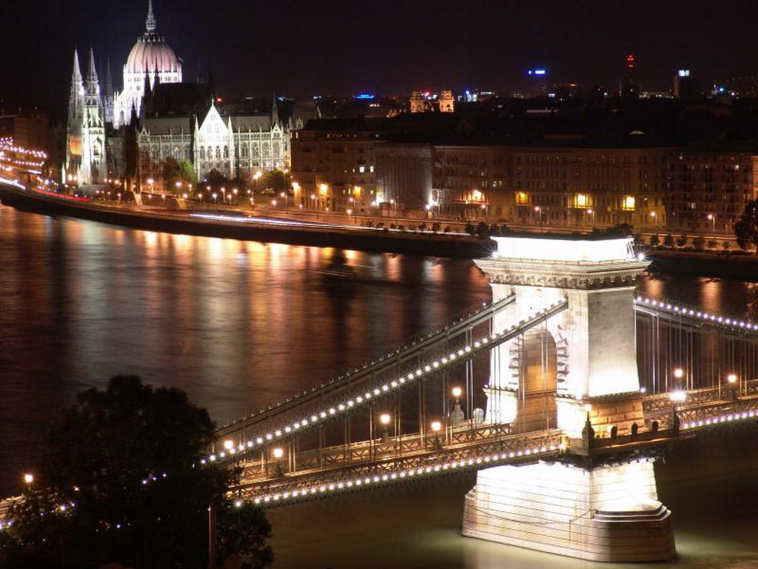

The phrase „Central European” is not nearly a geographical definition; it refers to the fact that the Hungarian capital, Budapest, is more than just a capital of a small country with 10.5 million inhabitants. It is also the product of a larger area, of a particular European region: Central Europe. Located in central Europe’s Carpatian basin, Hungary has been the link in the chain connecting east and west for thousands of years. The ancestors of Hungarians, or Magyars, lived in the Ural Mountains. They had close linguistic ties with other Finno-Ugrian peoples and shared certain anthropological and cultural traits with the Turks.

Budapest’s most important attraction is the world-famous Buda-Castle on the west side of the Danube (granted UNESCO World Heritage Status in 1987). Budapest is the „City of Festivals”; several major cultural events are held in and around the city every year. There are over 90 major museums in the region; local history collections, regional architecture and small village museums provide additional perspectives on civilization in the area. The museums with intenationally-renowned collections include: the Museum of Applied Arts, the Museum of Fine Arts, the National Museum, the National Gallery, and the Ludwig Museum in Budapest. It is definitelly worth mentioning the Synagogue on Budapest’s Dohány Street because it is the largest synagogue in Europe and the second largest in the world. The Jewish Museum around the corner has a unique collection of traditional Jewish artifacts.

Budapest is visited by over 4 million tourst per year.
Both the hotel and the venue site will be near the city center. They are only 200 meters far from each other.

We advice everybody to go for discovery trip – Budapest by night is fascinating.

http://www.youtube.com/watch?v=e0wkokaybWA

OFFICIAL HOTEL

EXPO CONGRESS HOTEL ****
1101 Budapest, Expo tér 2 - Albertirsai ut 10, Hungary
The Expo Congress Hotel, next to the Hungexpo / Budapest Exhibition Centre, is situated in the green belt of Budapest, easily accessible with a private shuttle service.
You can relax at the spa and gym centre on the 12th floor of the Expo.
Wireless internet is available in the entire hotel free of charge.
The Pillango utca stop of the red metro is a 20-minute walk away.
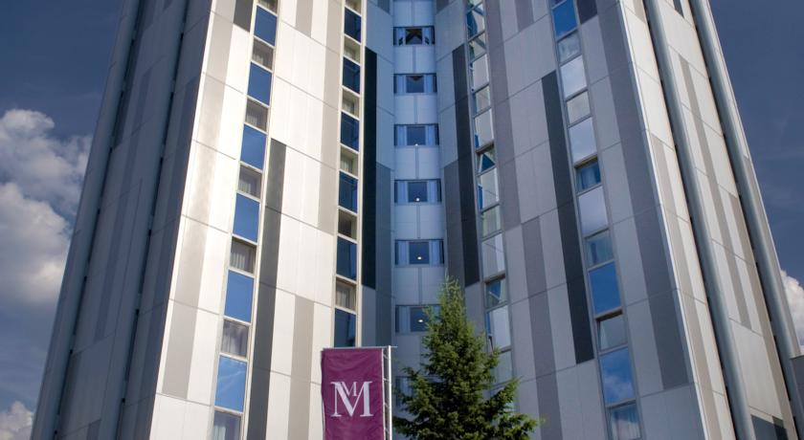
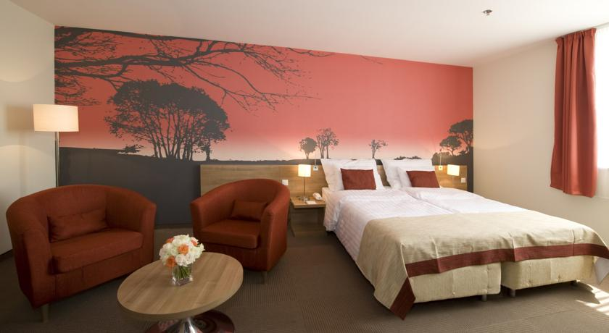

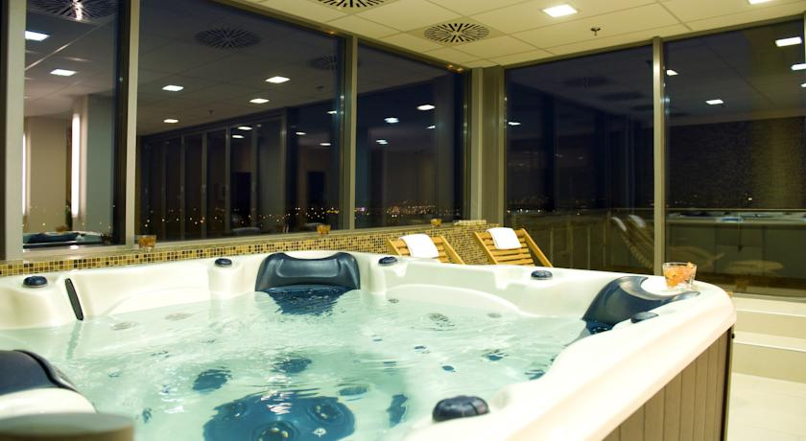
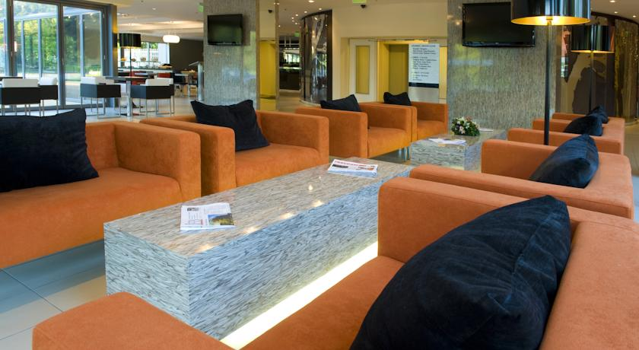

IMPORTANT NOTICE
Only the Organizing Committee is authorized to arrange hotel reservations, including accommodations before the Official Arrival Date, after the Official Departure Date and during the Championships, for all Official Participants (Athletes and Delegates), extra delegates, supporters, media and others.

ACCOMMODATIONS
The Organizer will provide free-of-charge accommodations and three meals per day, starting with dinner on Saturday, October 24 and finishing with breakfast on Monday, October 26, 2015 for:
- Three (3) children athletes from each National Federation.
The Official Arrival Date is Saturday, October 24, 2015.
The Official Departure Date is Monday, October 26, 2015.

IMPORTANT NOTICE

All National Team Official Participants (athletes, delegates) must check in BEFORE the start of Technical Meeting (October 24,2015, 5:00pm). Any Official Participant not checked in by this deadline will be classified as an extra delegate and will be responsible for all of his or her own expenses.

Any judge, coach, or trainer who is not an Official Participant will be responsible for all of his or her own expenses. If your National Federation wishes to bring a judge, coach or trainer, it is recommended that your Federation select this individual to be an Official Participant for your Federation; otherwise, these individuals will be responsible for all of their own expenses. The same rule applies for family members.
NO EXCEPTIONS WILL BE MADE UNDER ANY CIRCUMSTANCES.

SPECIAL PACKAGES
SPECIAL PACKAGE RATES FOR OFFICIAL DELEGATES, EXTRA DELEGATES, SUPPORTERS, MEDIA AND OTHERS
The Organizing Committee has established a Full Special Package Rate, which includes two (2) nights accommodations with three (3) meals per day (breakfast, lunch and dinner), tickets to the Prejudging and Finals, tickets to the Farewell Banquet at a cost of EUR 200 per person in a double-bedded room or in a triple-bedded room.
Package for additional competitors is EUR 200 (which includes participation fee of EUR 50).
The Organizer has also established Partial Special Package Rates as follows:
- Partial Special Package Rate, which includes tickets to the Prejudging and Finals, tickets to the Farewell Banquet at a cost of EUR 50 per person.
IMPORTANT NOTICE: anybody wishes to have a Partial Special Package must inform the Organizing Committee latest till September 30th, 2015.
For more information, please contact the Organizing Committee.

VENUE SITE
Hungexpo / Budapest Exhibition Centre (Hall “G”)
H-1101 Budapest Albertirsai út 10.
HUNGEXPO – Budapest, offers an ideal venue for all types of events for up to 15,000 participants. Located in the heart of Budapest – approx. 15 km (a 20-minute drive) from the international airport and 4 km from the downtown – the establishment covers 36 hectares with landscaped environment and 8 halls which can provide the ideal venue for hosting any type of events all the year round.
The Hall G with its available column-free indoor space can be divided into two sections with movable walls, making it perfectly suitable for simultaneous events. With its flawless aesthetics and high-quality equipment, this new multifunctional hall is an ideal venue for state-of-the-art events with 5000 participants, too.
The IFBB European Children Fitness Championship and Hungarian Fitness, Bikini Fitness World Cup will be organized with Vitalade-Fitbalance IFEX International EXPO in Hall G.
HOTEL SECURITY DEPOSIT
A hotel security deposit of EUR 50 per person is required upon check-in for incidental and personal expenses that may arise (telephone, mini-bar, laundry, room service, etc.). The unused portion of this deposit will be refunded at check-out in the same currency as remitted. In order to facilitate matters, the chief delegate or team leader will be asked to provide a credit card or cash to cover the deposit for the entire team. This individual will be fully responsible for any and all expenses incurred by any members of his or her team.
PLEASE ADVISE YOUR TEAM BEFORE DEPARTURE NOT TO CREATE ADDITIONAL EXPENSES.
AIRPORT
The official arrival airport is the Liszt Ferenc International Airport in Budapest. The Organizing Committee will pick you up at the airport on arrival and transport you to the Official Hotel. It is very important that every National Federation provide to the Organizing Committee complete arrival details of its team, including the number of people in its delegation.
The organizer shall arrange the transportation between the airport and the hotel on Saturday, October 24th, 2015 for EUR 10 per person and the transportation between the hotel and the airport on Monday, October 26th, 2015, for EUR 10 per person, based on the stated times of arrivals and departures.
Please notify the Organizing Committee the details of your arrival time no later than 14 days before the Championships, so that suitable transportation can be arranged for your National Team members.
It is very important that every National Federation provides the Organizing Committee with complete arrival details of its team, including the number of people in its delegation.
Your cooperation is essential to ensuring adequate transportation for your team.
EARLY ARRIVALS / LATE DEPARTURES
Any National Federation, including any of its individual team members, arriving before the Official Arrival Date of October 24 , 2015 and/or staying on after the Official Departure Date of October 26, 2015 will be responsible for all of their own expenses, including arranging their own transportation between the airport and the hotel. Accommodations before the Official Arrival Date and after the Official Departure Date will be approximately EUR 80.00 per day for a twin-bedded room with breakfast and dinner. You must notify the Organizing Committee of any early arrivals and/or late departures not later than September 30, 2015.
IMPORTANT NOTICE
Any National Federation team members arriving before the Official Arrival Date of October 24, 2015 and/or staying on after the Official Departure Date of October 26, 2015 will be responsible for their own transportation.
VISAS
A valid passport is required to enter the territory of the European Union. EU-country citizens do not require a visa. All other persons should consult the Hungarian Embassy in their country to determine if they require a visa. An Official Letter of Invitation will be made available if required.
CATEGORIES OPEN FOR COMPETITION
EUROPEAN CHILDREN FITNESS CHAMPIONSHIPS
FITNESS BOYS: BORN
up to 12 years of age - 2003
from 13 up to the 15 years of age 2002-2000

FITNESS GIRLS:
up to 7 years of age - 2008
from 8 up to the 9 years of age 2007-2006
from 10 up to the 11 years of age 2005-2004
from 12 up to the 13 years of age 2003-2002
from 14 up to the 15 years of age 2001-2000
Children compete in their own category during the whole year (until the 31st of December) in which they reach upper age limit of their category.
Maximum duration of the routine for all categories is 90 seconds. This is a one-day contest and will be scored according to the IFBB Rules for such an event.

Note: According to the IFBB Rules for children fitness!
Skin correction using oil or color is prohibited at the competition of children!
The use of self-tuning products is permitted. Bronzers are not permitted.
Compulsory attire for quarter turns rounds:
- Girls: black top bra and black tight shorts without shoes.
- Boys: black tight shorts without shoes.
Detailed information in IFBB Rules: Section 10: Children Fitness, Art. 6.
Team Competition: every nation can form team of 3-6 members from among their children competitors, who can perform a kind of show exercise with a two-minute music.
HUNGARIAN FITNESS, BIKINI FITNESS WORLD CUP:
- Women’s Fitness: one open category
- Women’s Bikini-Fitness: up to166 cm
- Women’s Bikini-Fitness: over 166 cm
PARTICIPATION AND REGISTRATION FEE
EUROPEAN CHILDREN FITNESS CHAMPIONSHIPS

A-Team
- Each IFBB-affialiated National Federation may entern an A-Team. The maximum allowable number of competitors in the A-Team is 7 (5 girls and 2 boys).
A maximum allowable number of A-Team competitors per National Federation in any one individual category shall not exceed two (2).
- The Organizer will provide free-of-charge accomodation, meals, and access to the Prejuding, Finals and Farewell Banquett to 3 (three) of the A-Team competitors. National Federation shall pay a Registration Fee (EUR 50 per person) for each of these three A-Team competitors.
- Offials delegates (max. 2 persons), extra delegates (unlimited) and additional
A-Team competitors (max. 4 athletes) will have to pay EUR 200 per person for the Special Package, what includes the IFBB Registration Fee.
- The A-Team competitors shall compete for placings and awards, including the Best National Team award.
- A National Federation must fully declare its A-Team competitors on the Final Enry Form and must register the A-Team competitors upon check-in the official hotel, failing wich any undeclared competitor shall be responsible for all his or her expenses.
B-Team
- Each National Federation may enter a B-Team, which is unlimited.
- The National Federation shall be obliged to pay the Full Package Rate of EUR 200 for each B-Team competitor. This package shall comprise the competitor accomodation, meals, onsite transportation, and access for Prejudging, Finals and Farewell Banquet and includes the IFBB Registration Fee.
- The B-Team competitors shall compete for placings and awards, excluding the Best National Team award.
- A National Federation must fully declare its B-Team competitors on the Final Enry Form and must register the B-Team competitors upon check-in the official hotel, failing wich any undeclared competitor shall be disqualified.
HUNGARIAN FITNESS, BIKINI FITNESS WORLD CUP
A-Team
- Each IFBB-affialiated National Federation may enter an A-Team. The maximum allowable number of competitors in the A-Team is 3 (three). A maximum allowable number of A-Team competitors per National Federation in any one individual category shall not exceed two (2).
- Every A-Team athlete and delegate coming to participate in the Hungarian Fitness,Bikini Fitness World Cup will have to pay the Special Package Rate of EUR 200. This package shall comprise the competitor accomodation, meals, onsite transportation, and access for Prejudging, Finals and Farewell Banquet and includes the IFBB Registration Fee.
- The A-Team competitors shall compete for placings and awards, including the Best National Team award.
- A National Federation must fully declare its A-Team competitors on the Final Enry Form and must register the A-Team competitors upon check-in the official hotel, failing wich any undeclared competitor shall be responsible for all his or her expenses.
B-Team
- Each National Federation may enter a B-Team, which is unlimited.
- Every B-Team athlete and extra delegates coming to participate in the World Cup will have to pay the Special Package Rate of EUR 200. This package shall comprise the competitor accomodation, meals, onsite transportation, and access for Prejudging, Finals and Farewell Banquet and includes the IFBB Registration Fee.
- The B-Team competitors shall compete for placings and awards, excluding the Best National Team award.
- A National Federation must fully declare its B-Team competitors on the Final Enry Form and must register the B-Team competitors upon check-in the official hotel, failing wich any undeclared competitor shall be disqualified.
All World Cup participants must poses a valid IFBB International Card. If not, they should pay EUR 30 annual fee or buy a new Card.
ATHLETES WITHOUT DELEGATES
All Athletes competing at IFBB World Cup must be Members in Good Standing of their National Federations. Any Athlete who arrives without a Delegate must carry an Official Letter of Authorization of Participation from her National Federation, failing which the Athlete will not be allowed to participate.
DOPING CONTROL
Doping controls of the IFBB World Cup partcipants will be conducted by the IFBB Medical Commission pursuant to the IFBB Anti-Doping Rules (2015 edition) using a WADA accredited laboratory.
In order to compete in the Championships, all the World Cup competitors will be required to sign a Doping Control Consent & Waiver of Liability Form at the Registration.
IMPORTANT NOTICE
Doping controls may be conducted using any or all of the following methods:
1. Random Selection: A number of athletes selected at random throughout the event e.g. at Weigh-in or Prejudging.
2. Weighted Selection: A number of athletes selected at random from among the top finalists e.g. at Finals
*The IFBB reserves the right to Target Test any athlete
The IFBB is a Signatory to the WADA Code. Participating National Federations have a duty and an obligation to ensure that their National Team athletes are competing drug-free at IFBB international competitions.
SECRETARIAT
The Organizing Committee will maintain a Secretariat at the Official Hotel, from 12:00 am October 24, 2015 to 11:00 am October 26, 2015. You may obtain information and assistance from the Secretariat.
PASSPORT/MUSIC
All competitors must provide their PASSPORT and MUSIC at weigh in/height measurement, failing wich the competitor will not be registered. The music must be on CD, at the start of the CD. The Athletes’s name must be affixed on the CD for identification purposes.
IMPORTANT NOTICE
The use of profane, vulgar and/or offensive language
is strictly prohibited in the music.
NATIONAL ANTHEM/NATIONAL FLAG
All National Federations must bring with them to Budapest the music of their National Anthem (shortened version only) on CD. This must be on a separate CD to any posing music. All National Federations shall bring with them to Budapest their National Flag. The flags must be manufactured of dense silk and must measure no more than 2.5 meters x 1.5 meters.
*Note: For all European National Federations, the EBFF already has a copy of all National Anthems on CD.
PARADE OF NATIONS
The dress code for all Delegates and/or officials taking part in the Parade of Nations is the IFBB official uniform. One (1) delegate per country must take part in the Parade of Nations.
JUDGES
In order to assist the IFBB Judges Committee in their selection of judges for these Championships, please forward your nomination for judges from your National Federation as soon as possible but no later than September 30, 2015 to:
Pawel Filleborn
Chairman
IFBB Judges Committee
Fax: +48 22 642 73 51
E-mail: pawelfilleborn@gmail.com
PLEASE DO NOT FAX YOUR NOMINATIONS TO IFBB HEADQUARTERS.
The names of those judges submitted in advance will receive priority consideration. All international judges must bring their international judge’s cards to Budapest.
IMPORTANT NOTICE
All judges must attend the Techncial and Judges Meeting. If a judge is absent from this meeting, he or she will not judge.
MEDIA ACCREDITATION
All media accreditation, accept local media, shall be controlled by the IFBB. All persons wishing to obtain media accreditation for this event must register with the IFBB by completing and signing an IFBB Media Accreditation Form, said form which must be remitted to the IFBB by e-mail at info@ifbb.com not later than September 15, 2015.
IFBB MEDIA ACCREDITATION FORM
COMPETITOR INFORMATION FORM
This form must be completed by each competitor BEFORE the weigh-in/height measurement and must be given to the IFBB Registrar at the weigh-in/height measurement. This information is used to promote the competitor in the press, on TV, the website and other media.
COMPETITOR INFORMATION FORM
GREEN CARDS
Green cards, used to limit access to the Weigh-in and backstage area during the Prejudging and Finals, will be distributed at the Technical and Judges Meeting as follows:
five (5) or more competitors - two (2) green cards
less than five (5) competitors - one (1) green card
IF A NATIONAL FEDERATION DOES NOT ATTEND THE TECHNICAL AND JUDGES MEETING, IT WILL NOT BE ISSUED A GREEN CARD.
BACKSTAGE ACCESS/DRESSING ROOM ACCESS
Access to the backstage and/or dressing room areas shall be strictly limited to essential personnel only. Coaches and trainers who assist athletes in the dressing room area must be of the same sex as the athlete they are assisting.
CAMERA/VIDEOTAPE EQUIPMENT
Camera and/or videotape equipment shall be strictly prohibited in the backstage and/or dressing room areas except when used by IFBB-authorized media persons and, in any event, these devices shall be strictly prohibited in the dressing room area.
TIME DIFFERENCE
GMT +1 hour
CURRENCY
The national currency in Hungary is the Hungarian Forint. One Euro is approximately equal to 315 Forint (one USD is approximatelly equal to 270 Forint) but the rates can fluctuate. All major credit cards are widely accepted at most major hotels, department stores and restaurants. You may be requested to show your passport.
CLIMATE
During the month of October the average temperature is +13 ° C, eventual rain.
ELECTRICAL CURRENT
The electrical outlets are 220 V, 50 Hz, socket/plug of Type C (europlug).
LANGUAGE
The official language in Budapest is Hungarian. English is widely spoken in hotels, restaurants, shopping centers and tourist areas.
FAILURE TO HONOR FINAL ENTRY FORM DEADLINE
Deadlines are set to assist the Organizer with arranging accommodations, meals, onsite transportation and other Championship activities. A failure to respect these deadlines is a breach of IFBB Rules. The IFBB reserves the right to deny participation to any National Federation that does not respect the deadlines for submitting the Final Entry Form.
If a National Federation fails to respect the deadline written on the Final Entry Form, each “Official Participant” from that federation will be required to pay all of his or her own expenses, including accommodations, meals, onsite transportation, and access to the Prejudging, Finals and Farewell Banquet.
MISREPRESENTATION
Misrepresentation is a serious breach of the IFBB Code of Ethics and occurs when an “official” of a National Federation deliberately misrepresents the number of Athletes and Delegates so as to obtain free-of-charge accommodations, meals, onsite transportation, access to the Prejudging, Finals and Farewell Banquet, and other amenities at the expense of the Organizer.
Part of this misrepresentation may be a false claim that a person is an Athlete only to have that so-called Athlete fail to officially register as a competitor at the Weigh-in or, once having officially registered, fail to compete.
Any National Federation found guilty of misrepresentation will be immediately disqualified from the Championships and will be fined an amount equal to the Special Package Rate for each person involved.
MEDICAL WITHDRAWAL
Once officially registered, no Athlete may withdraw from competition without the prior approval of the IFBB Chief Judge. It is not acceptable for a National Federation to unilaterally withdraw an Athlete without the prior approval of the IFBB Chief Judge, who has the right to verify the reason for the withdrawal.
Any National Federation that fails to seek the prior approval of the IFBB Chief Judge before withdrawing an Athlete shall, for that Athlete’s non-participation, be fined an amount equal to the Special Package Rate.
FAILURE TO COOPERATE
Failure to cooperate with the Organizing Committee is contrary to the IFBB Code of Ethics and may result in disciplinary measures being taken by the IFBB against the offending National Federation.
CORRESPONDENCE/CONTACT INFORMATION
Please send all correspondence to:
Mr. István Huber
President
Hungarian Federation of Bodybuilding and Fitness
and
Ms. Viola Vargha
General Secretary
Hungarian Federation of Bodybuilding and Fitness
Phone: +36 30 960 81 86
E-mail: ifbb.huber@gmail.com
Please copy all correspondence to:
International Federation of Bodybuilding and Fitness
Dr. Rafael Santonja
IFBB President
Phone: +34 91 535 2819
Fax: +34 91 535 0320
E-mail: headquarters@ifbb.com
TENTATIVE SCHEDULE OF ACTIVITIES
The following schedule of activities is tentative and is therefore subject to change. Please check regularly for updates:

October 24, Saturday:
12:00-17:00: Arrival of National Teams
17:00-19:00: Registration, Technical and Judges Meeting
19:00-21:00: Dinner

October 25, Sunday:
07:00 - 09:00: Breakfast
09:30 - 17:00: European Children Fitness Championships
12:00 - 14:00: Lunch at the venue site
17:00 - 18:00: Hungarian Fitness and Bikini Fitness World Cup
20:30 - 22:00: Dinner, Farewell Banquet

October 26th, Monday:
07:00 – 10:00: Breakfast
Up to 11:00: Departures

PRELIMINARY ENTRY FORM
The deadline date for the Preliminary Entry Form is September 15, 2015. National Federations must return the Preliminary Entry Form to the Organizing Committee as soon as possible but not later than deadline date, confirming your Federation’s intent to participate. If at this time you do not know the actual names of the Official Participants (Athletes and Delegates, including judges), please indicate the total number of individuals from your National Federation who will participate in the Championships.
FINAL ENTRY FORM
The deadline date for the Final Entry Form is October 12, 2015. National Federations must submit the actual names of all Official Participants (Athletes by age category and Delegates, including judges). You must also include flight arrival and departure information. In order to guarantee hotel accommodations for your team, the Final Entry Form must be returned not later than the deadline date. Your co-operation is essential to ensuring your accommodations at the hotel and adequate transportation for your team.
FINAL ENTRY FORM
It is the responsibility of the president or general-secretary of each participating National Federation to ensure that all National Team members (athletes, delegates, extra delegates) are fully aware of the rules and regulations governing participation at these Championships, to include the statements contained within this Inspection Report.
If any of your athletes and/or delegates are traveling and arriving separate from your Team Manager or Chief Delegate, you must ensure they are familiar with the rules and regulations contained within the Inspection Report.

