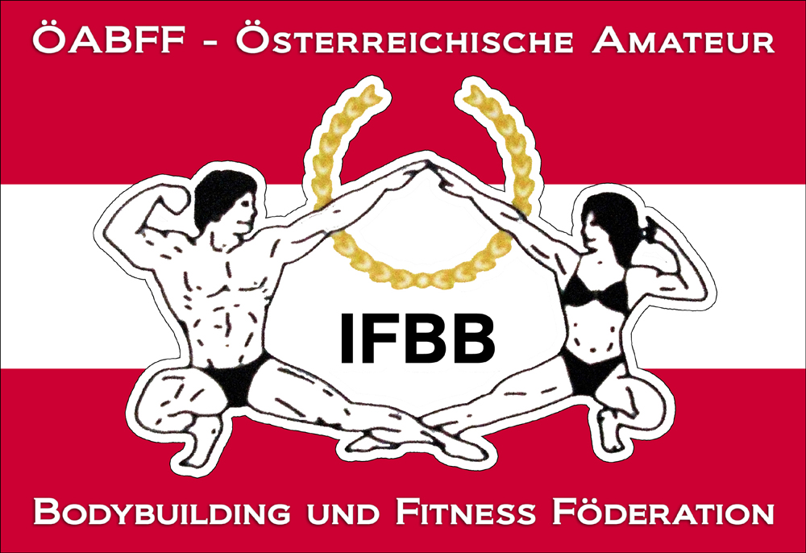

IFBB International Austria Cup

11th of September (Saturday) 2016
VAZ St. Pölten, Kelsengasse 9, 3100 St. Pölten

Date: 11th of September 2016
Organizer: Austrian Amateur Bodybuilding and Fitness Federation/IFBB-Austria
Venuesite: VAZ St. Pölten, Kelsengasse 9, 3100 St. Pölten
Weigh in: 12.00 – 14.00
Competition: Prejudging: 14.00; Finals: In connection to the semies.
Entry form: Please not later than 27th of August 2016 to w.schober@ifbb-austria.at Our guests are kindly requested not to nominate more than 10 athletes from their country for that event.

Categories:

Junior Men´s Physique open
Men´s Physique -178cm
Men´s Physique +178cm
Masters Physique open

Junior Classic Bodybuilding: open
Masters Classic Bodybuilding open
Classic Bodybuilding - 175 cm
Classic Bodybuilding + 175 cm

Junior Bodyfitness: open
Masters Bodyfitness: open
Women Bodyfitness: open
Women´s Physique: open

Junior Bodybuilding: open
Masters Bodybuilding: open
Bodybuilding - 85 kg
Bodybuilding - 95 kg
Bodybuilding + 95 kg

Junior Bikini Fitness: open
Masters Bikini Fitness: open
Bikini Fitness - 163cm
Bikini Fitness - 169cm
Bikini Fitness + 169cm

Rewards: Certificates for all finalists, cup for first 3 of each category.
Tickets:
Advance Sale via www.ifbb-austria.at
Prejudging + Finals : € 25.-per person (starting at a group of 5 people, free seating)
At the gate:
Prejudging + Finals : € 35.- (free seating)
THE IFBB HAS BANNED ALL TANS THAT CAN BE WIPED OFF.
Looking forward to welcome you all in St. Pölten.
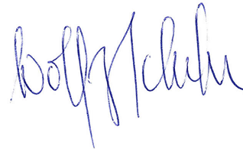
Dr. Wolfgang Schober
President IFBB-Austria

